@title Math Assessment: Combinatorics and Geometry Problems

@description This assessment contains two generated math questions focusing on counting combinations and determining dimensions of packed objects, aligned with the curriculum.

// Question 1

@question Each student in a club selects a meal consisting of 1 main dish and 1 drink. The table shows the options available for each item. How many different meal combinations are possible?

## Meal Choices

|  |  |
| --- | --- |
| Main Dish | Drink |
| Pizza | Juice |
| Burger | Soda |
| Salad | Water |
| Pasta |  |

@option Three

@option Four

@option Six

@option Nine

@@option Twelve

@instruction Select the correct option from the choices provided.

@difficulty easy

@order 1

@explanation There are 4 main dishes and 3 drinks available, so the total number of meal combinations is \(4 \times 3 = 12\).

@subject Quantitative Math

@unit Data Analysis & Probability

@topic Counting & Arrangement Problems

@plusmarks 1

// Question 2

@question The top view of a rectangular package containing 12 tightly packed spheres is shown. If each sphere has a radius of 3 centimeters, which of the following are closest to the dimensions, in centimeters, of the rectangular package?

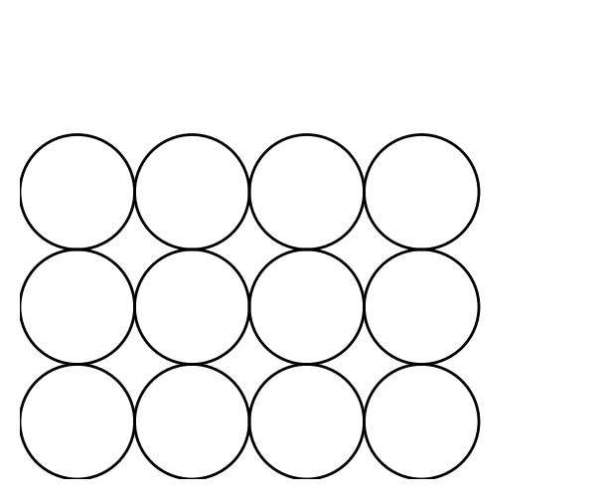

@option 3 \times 6 \times 9

@option 6 \times 9 \times 12

@option 3 \times 12 \times 18

@@option 6 \times 12 \times 18

@option 9 \times 12 \times 18

@instruction Select the correct option from the choices provided.

@difficulty moderate

@order 2

@explanation The top view shows a 3 by 4 grid of spheres. Each sphere has a radius of 3 cm (diameter 6 cm). The package’s length is \(4 \times 6 = 24\) cm, width is \(3 \times 6 = 18\) cm, and height is 6 cm (one layer). The closest option is \(6 \times 12 \times 18\), assuming a minimal bounding box.

@subject Quantitative Math \(subjects: Problem Solving, Algebra, Geometry and Measurement, Numbers and Operations, Data Analysis & Probability, Reasoning; with specific units and topics as provided\)

@unit Geometry and Measurement

@topic Area & Volume

@plusmarks 1